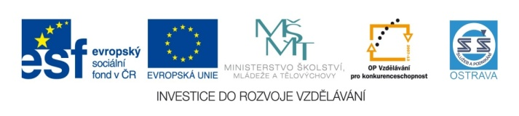 VY_22_INOVACE_AJM34264ČER
Výukový materiál v rámci projektu OPVK 1.5 Peníze středním školám
Číslo projektu: | CZ.1.07/1.5.00/34.0883
Název projektu: | Rozvoj vzdělanosti
Číslo šablony: | II/2
Datum vytvoření: | 12.11. 2012
Autor: | Mgr. Iva Černá
Určeno pro předmět: | Anglický jazyk
Tematická oblast: | Člověk a jeho svět
Obor vzdělání: | 69-41-L/01 Masér sportovní a rekondiční 3. ročník
Název výukového materiálu: | Spojovací výrazy
Druh výukového materiálu: | Pracovní list s přehledem spojovacích výrazů, cvičeními a textem
Čas: | 35 minut
Využití: | Pracovní list poskytuje přehled spojovacích výrazů a jejich významů – nácvik logického strukturování výpovědi

Spojovací výrazy (linking words) – základní přehled

BUT – ale
Ex.: Peter is a great footballer but I do not like the way he behaves.

HOWEVER – avšak
Ex.: However Peter is a great footballer, I do not like the way he behaves.

SO – tak, takže
Ex.: I love Mary, so one day I will marry her.

THEREFORE/that´s why – proto
Ex.: I really want to pass the final exam therefore I am studying very hard these days.

BECAUSE – protože
Ex.: I am studying really hard these days because I want to pass the final exam.

SO THAT – aby
Ex.: I want to earn enough money so that I could buy a new car.
Všimněte si: Tentýž význam vytvoříte použitím tzv. účelového infinitivu.
Ex.: I want to earn enough money to buy a new car.

Ex. 2: He is trying to help her so that she could have more free time.
Všimněte si: Tady převod na účelový infinitiv není možný, protože podměty v souvětích jsou různé.

ALTHOUGH – ačkoliv
Ex.: Although I was learning hard, I failed the exam.

- Choose the sentences where you can use the infinitive of purpose and change them.
- I want to go to Egypt so that I could see the pyramids.
- Peter wants to get married so that his girlfriend felt happier.
- Jenny would like to go to London so that she could see the London Eye.
- I am studying to become a masseur so that I could help people.
- Our teachers want us to be good so that we could become good at our work.
- People take massages so that they felt better.

- Fill in missing linking words:
I have a sister Barbora. She has long brown hair with pink stripes. She has blue eyes and long eye-lashes. __________She is not slim and fit.
She likes green and purple colors. __________ me and my sister love most of animal, we do not like some of them, for example snakes. She likes dogs ____ her favorite animal is a horse.
My sister is a crazy person.__________ she is explosive, she can also be patient.
I also have a very special uncle. He comes from Croatia, ____________ he is different from usual uncles. His name is Franio Župarič. He has short gray hair, very tall figure and a beer belly. Barbora and Franio both like drinking lager beer. He likes football, _____ she is not very keen on it. As I have said, he is Croatian. __________ his Czech and German are very good too. He is a funny person _____ he can also be quite serious.

