VY_22_INOVACE_AJOP40764ČER

Výukový materiál v rámci projektu OPVK 1.5 Peníze středním školám

Číslo projektu: | CZ.1.07/1.5.00/34.0883
Název projektu: | Rozvoj vzdělanosti
Číslo šablony: | II/2
Datum vytvoření: | 19. 11. 2012
Autor: | Mgr. Iva Černá
Určeno pro předmět: | Anglický jazyk
Tematická oblast: | Reálie anglicky mluvících zemí
Obor vzdělání: | 31-43-M/01 Oděvnictví 4. ročník
Název výukového materiálu: | Cestování do Velké Británie
Druh výukového materiálu: | Pracovní list s informačním textem a otázkami na pochopení textu
Čas: | 20 minut
Využití: | Prohloubení slovní zásoby o cestování, práce s mapou Velké Británie

What country can you see in the map? Can you recognize any towns or cities? What do you know about them?

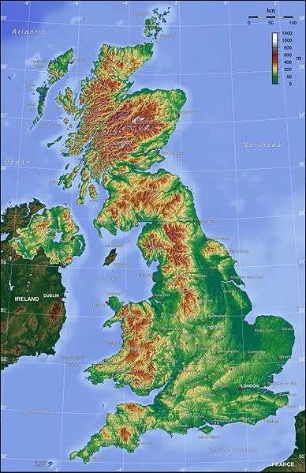

- Read the text below and answer following questions about travelling to Great Britain:

How many airports are there in London?
What do you have to be careful about when flying to London?
What are the 3 most important airports called?
What is interesting about Heathrow?
Which airport is the nearest to the city centre?
Which of the airports is the largest?
What are Calais and Dover?

By plane
When flying to the UK, you are most likely to arrive at one of London's five airports, although there are direct international flights to many other cities.
Recently, many airports in southern England have added "London" to their names. Be aware that just because an airport has London in its name doesn't necessarily mean that it is near to, or easily accessible from London.
Inner/ more convenient airports to London:
London Heathrow Airport is the world's busiest international airport. Situated 15 miles/24 km west of Central London, Heathrow offers a large choice of international destinations, with direct flights to most countries in the world.
Heathrow is massive, and is comprised of 5 terminals, with different tube stops, so do realize which one you are flying from prior to arrival.
- London Gatwick Airport , 30 miles/50 km south of London in Sussex, is the second-largest airport.
It is important to note that the North and South terminal are some distance from each other, so check first which one you will be flying from before arrival to avoid missing a flight if rushing late.
- London City Airport is the most central airport in London, situated 7 miles east of Central London. It is easy to get to the centre of town or Canary Wharf. Due to the short runway and noise restrictions, the airport is restricted to small sized and regional jets. As a result, service is more or less limited to UK domestic and Western European destinations - primarily financial centres such as Frankfurt, Madrid, Paris, Zurich, etc.

By coach
International bus service runs from many cities. Good service is offered by Eurolines bus company and Student Agency. The journey takes about 20 hours. There are two ways how to get over The English Channel – either by ferry running between Calais and Dover (the ports with the shortest distance between), or under the sea bed through the tunnel.

Zdroj informací o letištích: http://en.wikipedia.org/w/index.php?search=airports+in+uk&title=Special%3ASearch

